Basic Branching Model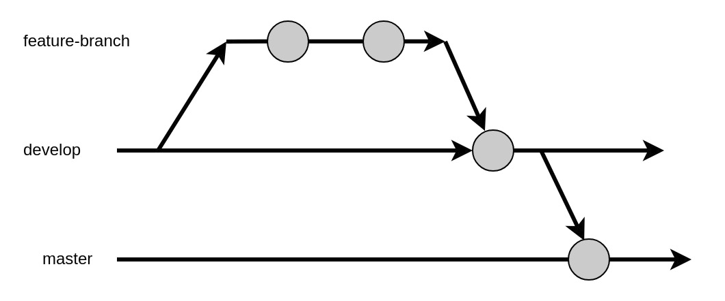

Single task Single branch

TASK- ID: GLAD-11

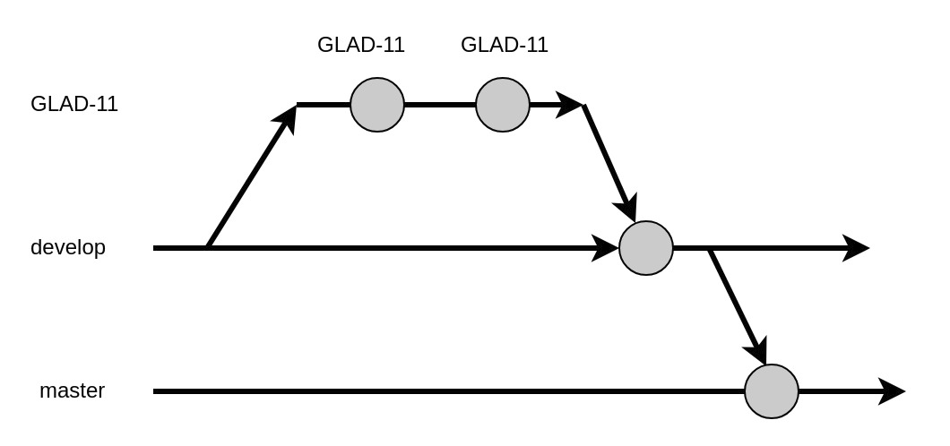

Multiple Sub-Tasks

TASK-ID:

Master Task: GLAD-33

* Sub-Task: GLAD-331 - Front-end task
* Sub-Task: GLAD-332 - Front-end task
* Sub-Task: GLAD-333 - Back-end task

